**Google Cybersecurity Certificate overview**

Hello, and welcome to the **Google Cybersecurity Certificate**! In this program, you will explore the growing field of cybersecurity, learn how cybersecurity is crucial to organizations and the people they serve, and develop relevant skills for a future career in the field. By completing the eight courses in this certificate program, you'll prepare for entry-level jobs in cybersecurity, such as cybersecurity analyst, security analyst, and security operations center (SOC) analyst. No prior experience in cybersecurity is required to complete this program.

**Enter a growing field**

Why are skills in cybersecurity in such high demand? The world is undergoing a digital transformation. Every day, global access to the internet is expanding, introducing more devices, more applications, and an even larger amount of data to the World Wide Web. As a result, threats, risks, and vulnerabilities are expanding and causing a significant amount of harm to organizations and people. Cybersecurity professionals are in high demand to help keep organizations, people, and data safe.

Throughout the program, you will have multiple opportunities to develop your cybersecurity knowledge and skills. You will explore concepts and scenarios to learn what an entry-level cybersecurity analyst must know and be able to do to thrive in the cybersecurity profession.

**Google Cybersecurity Certificate courses**

The Google Cybersecurity Certificate has eight courses that focus and build upon core concepts and skills related to the daily work of cybersecurity professionals, including foundational cybersecurity models and frameworks that are used to mitigate risk; protecting networks and data; using programming to automate tasks; identifying and responding to security incidents; and communicating and collaborating with stakeholders. Additionally, you will apply what you’ve learned in each course by completing portfolio projects that can be used to showcase your understanding of essential cybersecurity concepts to potential employers. The courses of the program are as follows:

1. [**Foundations of Cybersecurity**](https://www.coursera.org/learn/foundations-of-cybersecurity/home/week/1) *(current course)*
2. [**Play It Safe: Manage Security Risks**](https://www.coursera.org/learn/manage-security-risks/home/week/1)
3. [**Connect and Protect: Networks and Network Security**](https://www.coursera.org/learn/networks-and-network-security/home/week/1)
4. [**Tools of the Trade: Linux and SQL**](https://www.coursera.org/learn/linux-and-sql/home/week/1)
5. [**Assets, Threats, and Vulnerabilities**](https://www.coursera.org/learn/assets-threats-and-vulnerabilities/home/week/1)
6. [**Sound the Alarm: Detection and Response**](https://www.coursera.org/learn/detection-and-response/home/week/1)
7. [**Automate Cybersecurity Tasks with Python**](https://www.coursera.org/learn/automate-cybersecurity-tasks-with-python/home/week/1)
8. [**Put It to Work: Prepare for Cybersecurity Jobs**](https://www.coursera.org/learn/prepare-for-cybersecurity-jobs/home/week/1)

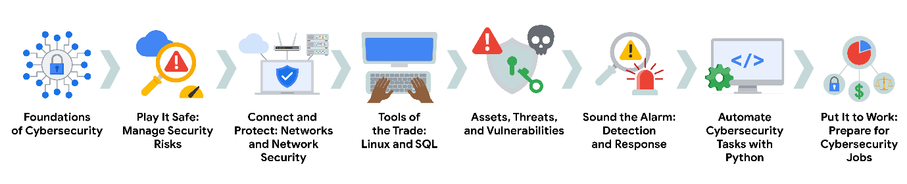

**Benefits for job seekers**

After completing all eight courses, Google Cybersecurity Certificate graduates have access to job search resources, courtesy of Google. You’ll have the opportunity to:

* Build your resume, participate in mock interviews, and receive job search tips through Big Interview, a job-training platform that’s free for program graduates.
* Improve your interview technique with Interview Warmup, a tool built by Google with certificate graduates in mind. Access cybersecurity-specific practice questions, transcripts of your responses, and automatic insights that help you grow your skills and confidence.
* Access thousands of job postings and free one-on-one career coaching with Career Circle. (You must be eligible to work in the U.S. to join.)
* Claim your Google Cybersecurity Certificate badge, and share your achievement on LinkedIn® professional networking services to stand out among other candidates to potential employers.
* Prepare for the CompTIA Security+ exam, the industry-leading certification for cybersecurity roles. You’ll earn a dual credential when you complete both the Google Cybersecurity Certificate and the CompTIA Security+ exam.

Congratulations on taking this first step to build your skills for a career in cybersecurity. Enjoy the journey!